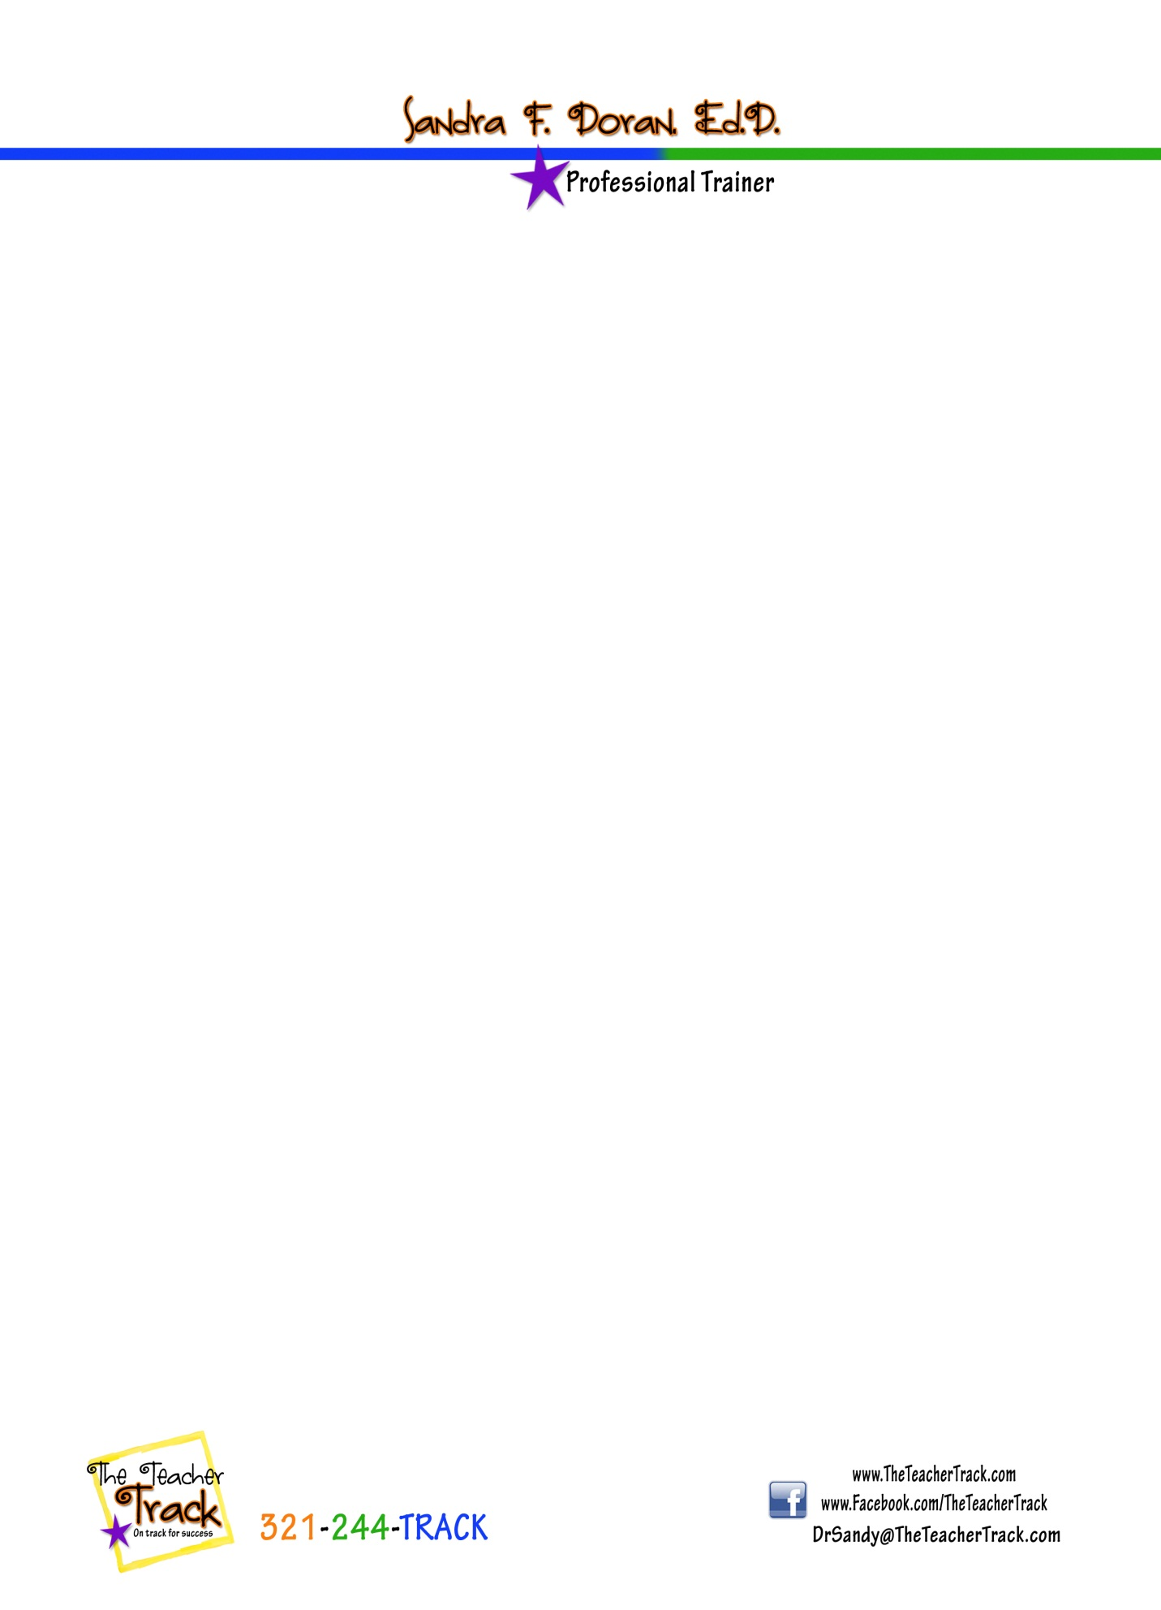

**VISIT BOOTH 607 FOR CONVENTION SPECIALS**

**~dAILY dRAWING FOR AN AUTOGRAPHED COPY OF *fINALLY fREE: tHE jAMES fINLEY sTORY***

***\*pERSONAL MESSAGE TO you FROM mARK fINLEY, sANDRA fINLEY dORAN, jAMES fINLEY***

***\*lIKE US ON fb AND sIGN UP FOR OUR NEWSLETTER AND BE ENTERED TO WIN AFTER THE cONVENTION!***

***~wRiter’S wORKSHOP, gUIDED reADING, AND THEMATIC READING dvdS***

***~cHILDREN’S STORIES WITH SPIRITUAL MESSAGE ON cd FOR lISTENING cENTERS***

***~dOWNLOADABLE SCORED sTUDENT wRITING sAMPLES WITH RUBRIC***

***~dOWNLOADABLE mATH pROFESSIONAL DEVELOPMENT MODULE***

**WRITE NOW!**

All teaching resources presented in this workshop can be found under the WRITING tab at [www.TheTeacherTrack.com](http://www.TheTeacherTrack.com)