**Adjusting Seat Height on Your Bicycle**

1. Sit on seat with one arm against a wall and your outside pedal all the way down.
2. Have a partner check for proper position. If your leg is bent too much, your seat needs to go up. If your leg fully extended, or can’t touch the pedal, your seat needs to go down.
3. Get off the bike and loosen the seatpost clamp with your multi-tool.
4. Raise or lower about what you think it might need.
5. Try it again.
6. Repeat until correct.

Mountain Bike Sequence of Skills

Working on bike

1. Adjust bike fit
2. Change flat
3. Adjust brakes

Riding Skills

1. Grip and body position
2. Braking
3. Cornering
4. Pumping
5. Riding over obstacles
6. Balance

* Slow riding
* Hopping

Road Safety

1. Riding signals
2. Traffic signs
3. Right of way
4. Car doors
5. Scanning
6. Head checks

Directions for Fixing a Flat Tire

You Need:

* Tire levers
* Patch kit
* Pen
* Bowl of water
* Pump

1. Make sure all air is out of the tube.
2. Use tire levers to pull one side of the tire out of the rim.
3. Remove tube (don’t forget to pull off the tube cap).
4. Put air in the tire to find the hole, use water if necessary.
5. Mark the hole with a pen, then scuff up an area large enough for the patch with sandpaper or rough metal.
6. Apply glue to the tube with enough area to fully glue the patch.
7. Let sit for five minutes.
8. Press patch on all around to get a good seal.
9. Inflate with a small amount of air to ensure a good patch job.
10. Put tube back in and tire over top.
11. Inflate tire to recommended PSI.
12. Don’t forget the tube cap!

**Pre-ride and Post-ride Inspections**

Pre-ride

1. Helmet is free of cracks and fits snugly.
2. Quick release lever is secured on front wheel.
3. Stem, seatpost, and seat are tight.
4. Tires feel properly inflated.
5. Brakes work properly.

Post-ride

1. Bike is clean and lubed.

Attack Position

Though you are constantly moving around on your bike, keeping a neutral base position is important for encountering all types of situations on a trail. The attack position prepares you for these situations.

Keep these things in mind to ride in the attack position:

1. Weight driving into your pedals (good fore-aft balance)
2. Knees bent (lower center of gravity, absorb bumps)
3. Hips back, torso level (better balance, more power)
4. Shoulders down (more arm range)
5. Elbows out (stronger)
6. Head up, eyes out (better balance)

Picture taken from *Mastering Mountain Bike Skills, 2nd Edition* By Brian Lopes

**Assignment**

Have a classmate record you as you ride up to, and through a corner. Your clip will be downloaded onto a computer and you will have the opportunity to critique your position. Answer the following questions based on your video review.

1. Of the six keys to a good attack position listed above, my video shows that I am best at ________________________________________________________________.

2. Of the six keys to a good attack position listed above, I found that I need to work on ________________________________________________________________.

3. The one thing that I will focus the most on in order to improve my attack position as I ride will be _____________________________________________________________.

Image taken from: http://www.google.com/imgres?imgurl=http://www.mundomaterial.eu/wp-content/uploads/2009/09/bicycle_diagram-en.gif&imgrefurl

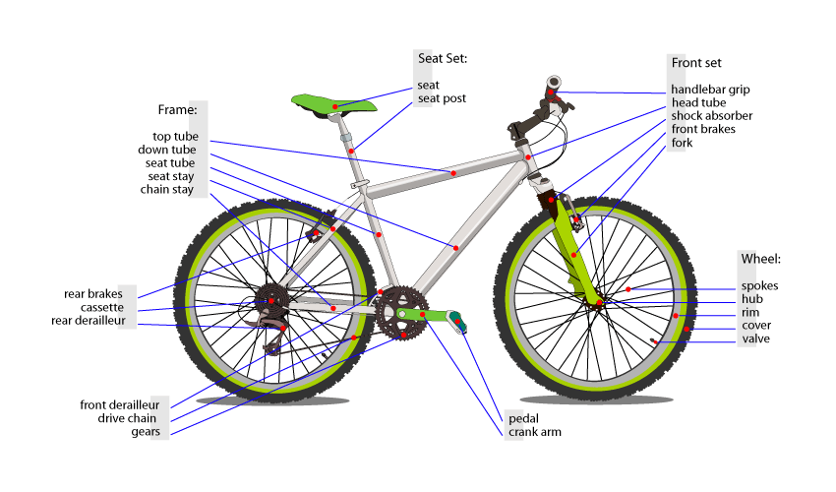

Image taken from: http://www.google.com/imgres?imgurl=http://upload.wikimedia.org/wikipedia/commons/thumb/e/e8/Bicycle_diagram-unif.svg/800px-Bicycle_diagram-unif.svg.png&imgrefurl

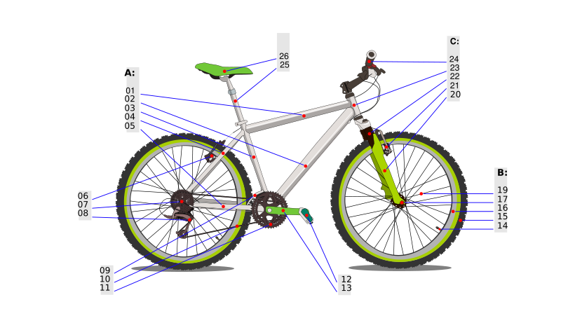

**Mountain Bike Tests**

**Skills Test**

Bike Maintenance

* Be able to remove a wheel and put it back on tightly.
* Be able to remove a tube and put it back properly.

**Riding Skills**

Points will be awarded as follows for each of the categories:

**1-lap timing**

|  |  |  |  |  |
| --- | --- | --- | --- | --- |
| 1:30 or less | 1:31-1:40 | 1:41-1:50 | 1:51-2:00 | 2:01+ |
| 10 points | 9 points | 8 points | 7 points | 5-6 points |

**Pumping**

|  |  |  |
| --- | --- | --- |
| Student flows easily through bumps and exits with accelerated speed. | Student looks somewhat comfortable through bumps and exits with some speed. | Student struggles through bumps and exits with little speed. |
| 10 points | 8 points | 6 points |

**Obstacles**

|  |  |  |  |
| --- | --- | --- | --- |
| Student rides easily over small and larger obstacles while in standing position. | Student rides with difficulty over small and larger obstacles while in standing position. | Student rides over small obstacles but is not able to ride over larger ones. | Student is not able to ride over obstacles of either size. |
| 10 | 8 | 5 | 0 |

**Slow Riding (30 Feet x 18 inches)**

|  |  |  |  |  |
| --- | --- | --- | --- | --- |
| 16 seconds+ | 14-15 seconds | 10-13 seconds | 8-9 seconds | Less than 8 seconds |
| 10 points | 9 points | 8 points | 6 points | 4 points |

**Written Test**

* Know the steps to performing a pre-ride and post-ride check
* Know the 4 keys to good cornering.
* Know parts of a bicycle according to the handout.
* Know road safety practices and hand signals.

Mountain Bike Test Name____________________

1. Name the four keys to good cornering and explain each
2. ________________________________________________________
3. ________________________________________________________
4. ________________________________________________________
5. ________________________________________________________
6. What five important things go in your pre-ride checklist?
7. __________________________________________
8. __________________________________________
9. __________________________________________
10. __________________________________________
11. __________________________________________
12. Imagine you are riding your bike down a busy city street. Name three practices that will help you get safely to where you are going.

a. _______________________________________________________

b. _______________________________________________________

c. _______________________________________________________

4. In one paragraph, name a country that uses bicycles as a primary source of transportation, and discuss the factors that might influence bicycle use there.

5. Draw stick figure pictures of a person using proper hand signals as if he/she were riding a bicycle. Be sure to label each one.

# 2010 Winter Olympics

Your team of five will compete in a number of events modified for gym competition. Your team will choose the country you want to represent and make your own replica flag, find your national anthem (extra credit for any student who learns to play the anthem with an instrument and perform it for the class). Country chosen must be represented by at least one athlete in the 2010 Winter Olympic Games in Vancouver. In addition, each of you will write a report on a famous Winter Olympian from your country in your English class.

Ideas for countries

* Canada
* Norway
* Japan
* Switzerland
* Germany
* Jamaica

Each student must participate in at least three events and no more than six. Each country must have a competitor for every event.

**Events.** The number in parentheses represents how many teammates must work together for this event.

1. **Curling** (3) – Athlete kneels on a skateboard and rolls a volleyball at a target across the gym after pushing off the wall and gliding. “Sweepers” use fans to direct the ball in a path that will hit the target. Scored event.

1. ________________
2. ________________
3. ________________

2. **Bobsled** (4) – All teammates start at designated spot, run to cart, two sit on cart while two push the cart around a course. Time is added for each missed turn or touched cone. Timed event.

1. _________________
2. _________________
3. _________________
4. _________________

3. **Luge** (1) – Athlete sits on scooter with feet on a second scooter and must push him/herself around course with hands. Time is added for each missed turn or touched cone. Timed event.

1. _________________
2. _________________

4. **Downhill Snowboard Slalom** (2) – One athlete pulls teammate standing on skateboard holding a rope through a slalom course. Time is added for each missed turn or touched cone. Timed event.

1. _________________
2. _________________
3. _________________
4. _________________

5. **Pairs Figure Skating** (2) – A pair will be scored out of 6 possible points in each of the following categories: Outfits, Music, 2 Lifts, 2 Jumps, 1 Throw, Sliding (feet on the floor and not walking), Synchronization, Enthusiasm (smiles). Routine must be at least 2 1/2 minutes long.

Three judges will award points for each area and all three scores will be averaged.

1. _________________
2. _________________

6. **Biathlon** (1) – Athlete runs 3 laps around gym, enters shooting area and fires a paintball gun at three targets, then returns to run three laps and shoot again, finishing in the center circle. Five seconds are added for each missed target. Timed event.

1. _________________
2. _________________

7. **Snowboard Cross** (2) – One athlete pushes teammate who is standing on a skateboard through a course. Done as a mass start with all teams competing together. Deliberate contact with other teams is illegal and will result in immediate disqualification. First one finished wins.

1. _________________
2. _________________
3. _________________
4. _________________

8. **Long Track Speed Skating** (1) – Athletes race around course maintaining contact with ground (sliding) at all times. Deliberate contact with other contestants is illegal and will result in a three second penalty per offense. First one finished wins.

1. _________________
2. _________________

9. **Short Track Speed Skating** (1) – Athletes race around center circle maintaining contact with ground (sliding) at all times. Deliberate contact with other contestants is illegal and will result in a three second penalty per offense. First one finished wins.

1. _________________

10. **3 on 3 Floor Hockey** (3) – 3 on 3 hockey with no goalie. Goals will be laid on end to create a smaller target with a no-entry zone in front of each goal. Round robin tournament with 10 minute games.

1. ___________________
2. ___________________
3. ___________________

Gold, Silver, and Bronze medals will be awarded to the top three athletes/teams in each event during closing ceremonies. Countries may send multiple athletes to compete in the same event as long as there are spaces provided on this form. An official team roster must be completed by the close of class on Friday, February 5.

# Winter Olympics Day 1 Training

Speed Skating Events

* 10 laps – sliding
* 3 x 1-minute wall sits
* stretch – quadriceps, butterfly, calf (gastrocnemius, soleus)

Curling

* 50 push-ups
* 40 squats
* 3 laps defensive slides

Biathlon

* 5 x 3-lap sprints
* 1 minute stomach breathing exercises in between sprints

Luge

* 4 down and back pushes
* 3 sets of curl-ups/crunches

Floor Hockey

* 4 x 4 down and back sideline sprints
* Dribble ball around track 5 times.

Pairs Figure Skating

* Work with partner to choreograph event
* Please provide me with a soundtrack soon

*When you have finished your specific training, you may do any other activities that you feel would benefit as you prepare.

# Winter Olympics Day 2 Training

Speed Skating Events

* 6 laps – sliding
* 30 straight leg lifts
* 20 lunges each leg
* stretch – hip flexors, quadriceps

Curling

* 30 push-ups
* 20 lunges each leg
* 3 laps defensive slides

Biathlon

* 5 x 3 laps at 80%
* After each set, grab a hockey stick, and use it to aim, trying to keep it pointed at target while breathing heavily

Luge

* 4 down and back pushes
* 3 sets of max. reps. chair dips

Floor Hockey

* 4 x 4 down and back sideline sprints
* 50 shots at goal

Snowboard Events

* 5 laps pulled or pushed (depending on event), weave between each cone around track
* 50 heal lifts
* 25 lunges each leg

Pairs Figure Skating

* Please provide me with a soundtrack soon

*When you have finished your specific training, you may do any other activities that you feel would benefit as you prepare.

Directions for Curling:

1. Each team will be given four attempts with the cumulative score being the official total.
2. Thrower must release ball by the time he/she reaches the release line. A release after the release line is a fault.
3. Fanners may not contact the ball with their fans. Contact results in a fault.
4. The ball must remain in forward motion at all times. A ball that has stopped forward motion constitutes a fault.
5. A fault results in a scratch for that attempt.

Officials Needed:

1. Watch release before line.
2. Check to make sure ball is in continuous forward movement, and is not contacted by a fan.
3. Scorers (2).
4. Recorder

Directions for Downhill Snowboard Slalom

1. Each team will be given two attempts with the fastest attempt counting as the official score
2. Rider must begin race with hand touching the west wall of the gym, and travel down to the opposite end of the gym, weaving between four cones. Upon touching the opposite wall, rider must turn around and be pulled back to the starting wall. Time will stop when the rider has gone down and back two times.
3. If a turn is completely missed, team must go back to make the turn.
4. Three seconds will be added for each cone that is contacted, either by the rider or the puller.

Officials Needed:

1. Time keepers (2).
2. Recorder
3. Officials to watch turns and cones.

Score Sheet for Curling

|  |  |
| --- | --- |
| Country: | Score: |
| Throw 1 |  |
| Throw 2 |  |
| Throw 3 |  |
| Throw 4 |  |

Total:

Score Sheet for Curling

|  |  |
| --- | --- |
| Country: | Score: |
| Throw 1 |  |
| Throw 2 |  |
| Throw 3 |  |
| Throw 4 |  |

Total:

Score Sheet for Downhill Snowboard Slalom

|  |  |
| --- | --- |
| Country: | Team Members |
| Attempt 1 Time (add three seconds for each cone hit) |  |
| Attempt 2 Time (add three seconds for each cone hit) |  |
| Best Time |  |

Score Sheet for Downhill Snowboard Slalom

|  |  |
| --- | --- |
| Country: | Team Members |
| Attempt 1 Time (add three seconds for each cone hit) |  |
| Attempt 2 Time (add three seconds for each cone hit) |  |
| Best Time |  |

Directions for Bobsled:

1. Each team will race the course one time. The lowest time will be the winner.
2. Teams will all start off the sled. On the signal, two will run to the sled and get on, while two prepare to push.
3. There will be a 3 second penalty for each touched cone.
4. Time will stop when all four members of the team have crossed the finish line.

Officials Needed:

1. Stopwatches (2)
2. Watch cones
3. Recorder

Directions for Long-track Speed Skating

1. Racers will start two at a time from opposite sides of the track. All times will be recorded, with the lowest overall time declared the winner.
2. Race is done in socks only, with both feet maintaining constant contact with the ground.
3. Two seconds will be added every time a foot loses contact with the ground. A slip and fall does not count as lifting the foot.
4. Race will be four laps around the gym.

Officials Needed:

1. Stopwatches (2).
2. Recorder
3. Officials to watch feet of racers.

Score Sheet for Bobsled

|  |  |
| --- | --- |
| Country: | Hit Cones: |
| Time (with penalties) | |

Score Sheet for Bobsled

|  |  |
| --- | --- |
| Country: | Hit Cones: |
| Time (with penalties) | |

Score Sheet for Long-track Speed Skating

|  |  |
| --- | --- |
| Country: | Penalties: |
| Time (with penalties): | |

Score Sheet for Long-track Speed Skating

|  |  |
| --- | --- |
| Country: | Penalties: |
| Time (with penalties): | |

Directions for Snowboard Cross

1. Each team will consist of a snowboarder and a pusher.
2. Teams will complete two laps around a figure 8 course in heats of up to four.
3. After the first rounds, the top four teams will compete in a final heat which will decide the medal winners.
4. Intentional contact with other teams will result in immediate disqualification.
5. If a rider falls, he/she must retrieve his/her board and start at the spot of the fall.
6. If a team misses a turn, they must retrace their steps to make the turn.
7. Time stops when any part of racer crosses the finish line.

Officials Needed:

1. 4 stopwatches
2. One official per team to watch cones.
3. 8 as crashmat holders around sharp corners after straight stretches.

Directions for Luge

1. Participant completes one lap around the luge course.
2. 2 seconds will be added for each cone hit.
3. Missed turns must be fixed.
4. Participant must keep rear-end on one scooter, with feet on the second.
5. Time stops when any part of racer crosses the finish line.

Officials Needed:

1. Stopwatches (2).
2. Official to watch cones.

Score Sheet for Snowboard Cross

|  |  |
| --- | --- |
| Country: | Heat: |
| Time | |

Score Sheet for Snowboard Cross

|  |  |
| --- | --- |
| Country: | Heat: |
| Time | |

Score Sheet for Luge

|  |  |
| --- | --- |
| Country: | Hit Cones: |
| Time (with penalties) | |

Score Sheet for Luge

|  |  |
| --- | --- |
| Country: | Hit Cones: |
| Time (with penalties) | |

Directions for Biathlon

1. Participant will run three laps in the gym, enter the shooting area, fire one shot at each of three targets, run three more laps, enter shooting area, fire one shot at each of three targets, then run to center circle. Time stops when participant enters center circle.
2. Only the first three shots will be scored. A misfire by the gun can be re-fired.
3. 5 seconds will be added for each missed target.
4. Participant with the lowest overall team wins.

Officials Needed:

1. Stopwatches (2).
2. Shooting area official.

Directions for Short-track Speed Skating

1. Race is done in heats of up to four racers.
2. Racers must complete six laps around the center circle of the gym.
3. Each racer will compete in socks only.
4. Both feet will remain in constant contact with the ground. Two seconds will be added every time a foot comes off the ground.
5. One second will be added every time a foot touches the center circle.

Officials Needed:

1. 4 Stopwatches
2. One official to watch each racer’s feet, looking for lifted feet.
3. One official to watch each racer’s feet, looking for center circle violations.

Score Sheet for Biathlon

|  |  |
| --- | --- |
| Country: | Name: |
| Missed Targets:  Time: | |

Score Sheet for Biathlon

|  |  |
| --- | --- |
| Country: | Name: |
| Missed Targets:  Time: | |

Score Sheet for Short-track Speed Skating

|  |  |
| --- | --- |
| Country: | Name: |
| Lifted foot violations:  Center circle violations:  Time: | |

Score Sheet for Short-track Speed Skating

|  |  |
| --- | --- |
| Country: | Name: |
| Lifted foot violations:  Center circle violations:  Time: | |

Directions for Floor Hockey

1. Each team will consist of three players. There can be no goalie, but goals will be laid down on their sides to provide a short goal.
2. Games will be played as a round-robin with the best record winning gold. In case of a tie, we will count total number of goals scored, then subtract goals scored against.
3. 7th and 8th grades will play a two-day tournament, while HS will play a one-day tournament (due to time scheduling).
4. After all scores, the ball will be returned to the center for a face-off.
5. Sticks must remain below the waist for all swings, a 1 minute penalty will be assessed for high-sticking.
6. Checking is not allowed.
7. Shots taken beyond mid-court line will not count.

Officials Needed:

1. 1 stopwatch
2. 1 scorekeeper for each game
3. Officials to watch for rule violations

Scoring Sheet for Pairs Figure Skating

A total of six possible points are awarded for each category, with 48 points being the highest overall score. All judges’ scores will be averaged to find the actual score for each pair.

**Germany**

|  |  |
| --- | --- |
| Category | Score |
| Outfits |  |
| Music |  |
| 2 Lifts |  |
| 2 Jumps |  |
| 1 Throw |  |
| Sliding |  |
| Synchronization |  |
| Enthusiasm |  |

Total:

**Switzerland**

|  |  |
| --- | --- |
| Category | Score |
| Outfits |  |
| Music |  |
| 2 Lifts |  |
| 2 Jumps |  |
| 1 Throw |  |
| Sliding |  |
| Synchronization |  |
| Enthusiasm |  |

Total:

Grading Sheet for Olympics Unit

|  |  |  |
| --- | --- | --- |
| Name: | Points Possible: | Points Received: |
| Dress (for events only) | 15 |  |
| Effort (training and competition) | 15 |  |
| Participation (at least three events) | 18 |  |
| Flag | 7 |  |
| Anthem | 7 |  |
| Report | 18 |  |

Total: 80 Total:

Grading Sheet for Olympics Unit

|  |  |  |
| --- | --- | --- |
| Name: | Points Possible: | Points Received: |
| Dress (for events only) | 15 |  |
| Effort (training and competition) | 15 |  |
| Participation (at least three events) | 18 |  |
| Flag | 7 |  |
| Anthem | 7 |  |
| Report | 18 |  |

Total: 80 Total:

Grading Sheet for Olympics Unit

|  |  |  |
| --- | --- | --- |
| Name: | Points Possible: | Points Received: |
| Dress (for events only) | 15 |  |
| Effort (training and competition) | 15 |  |
| Participation (at least three events) | 18 |  |
| Flag | 7 |  |
| Anthem | 7 |  |
| Report | 18 |  |

Total: 80 Total:

Grading Sheet for Olympics Unit

|  |  |  |
| --- | --- | --- |
| Name: | Points Possible: | Points Received: |
| Dress (for events only) | 15 |  |
| Effort (training and competition) | 15 |  |
| Participation (at least three events) | 18 |  |
| Flag | 7 |  |
| Anthem | 7 |  |
| Report | 18 |  |

Total: 80 Total: